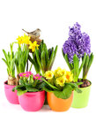

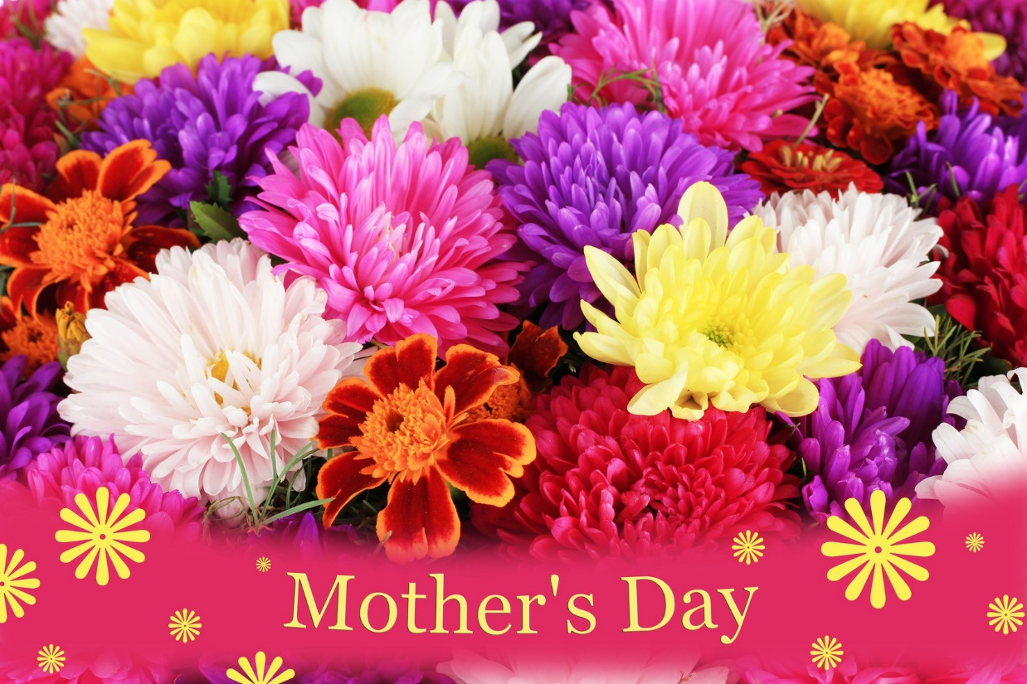

[This Photo](http://micifelicieco.it/senza-categoria/festa-della-mamma/) by Unknown Author is licensed under [CC BY-SA](https://creativecommons.org/licenses/by-sa/3.0/)